TRUTHLENS
Project-I
(ENCS305)
Submitted in partial fulfilment of the requirement of the degree of
BACHELOR OF TECHNOLOGY
to
K.R Mangalam University
by

PAKHI KUMARI (2301010213)

FAYYAZ AHMAD (2301010261)
Under the supervision of
Mrs. Mansi Kajal
Assistant Professor



Department of Computer Science and Engineering
School of Engineering and Technology
K.R Mangalam University, Gurugram- 122001, India
April 2025

CERTIFICATE

This is to certify that the Project Synopsis entitled, “TruthLens” submitted by Pakhi Kumari (2301010213) and Fayyaz Ahmad (2301010261) to K.R Mangalam University, Gurugram, India, is a record of Bonafide project work carried out by them under my supervision and guidance and is worthy of consideration for the partial fulfilment of the degree of Bachelor of Technology in Computer Science and Engineering of the University.

Mrs. Mansi Kajal

Signature of Project Coordinator

Date: 25th November 2025

INDEX

S.No | Title | Page No.
1. | Abstract | 2
2. | Introduction | 3
3. | Motivation | 4
4. | Literature Review | 5
5. | Gap Analysis | 6
6. | Problem Statement | 7
7. | Objectives | 8
8. | Tools/platform Used | 9
9. | Methodology | 10
10. | Experimental Setup | 11
11. | Evaluation Metrics | 12
12. | Results and Discussions | 13
13. | Conclusion and Future Work | 19
14. | References | 20

1. ABSTRACT
The rapid advancement of generative artificial intelligence has led to an increasing rise in deepfakes—synthetic media where images, videos, or audio are manipulated to convincingly imitate real individuals. While such technology has legitimate applications in entertainment, accessibility, and creative media, it also poses serious societal threats, including misinformation, identity fraud, cyberbullying, and political manipulation. To address this challenge, TruthLens has been developed as a multimodal deepfake detection system capable of analyzing images, videos, and audio to determine the authenticity of the input media.
TruthLens integrates machine learning, computer vision, and deep learning techniques to evaluate digital content and generate a confidence score indicating the likelihood of manipulation. The system leverages visual artifact detection, facial landmark inconsistencies, audio waveform anomalies, and temporal frame analysis to distinguish real media from AI-generated fabrications. A user-friendly web interface enables individuals, journalists, educators, and law enforcement stakeholders to verify content efficiently, making the tool practical in real-world scenarios.
The project aims not only to detect deepfakes but also to contribute to digital safety, media literacy, and responsible AI usage. With deepfake technology continuing to evolve, TruthLens represents an important step toward building trust, transparency, and accountability in the digital ecosystem.
Furthermore, TruthLens incorporates an adaptive learning approach, enabling the model to continuously improve detection accuracy as new deepfake techniques emerge. The system is trained on diverse datasets containing both authentic and manipulated media to ensure robustness across different manipulation methods and quality levels. To enhance usability, the platform provides clear visual and analytical explanations alongside the detection result, helping users understand the reasoning behind the classification rather than relying solely on a numeric score. This transparency fosters trust and supports educational outreach on media integrity. Overall, TruthLens serves as a scalable solution designed not only for current deepfake trends but also for future advancements in synthetic media generation.

2. INTRODUCTION
In the digital era, the growth of Artificial Intelligence and deep learning has revolutionized how multimedia content is created, shared, and consumed. Among these technological advancements, deepfakes have emerged as one of the most disruptive innovations. Deepfakes are AI-generated media—such as images, videos, or audio—designed to imitate real individuals with extremely high accuracy. While the technology can be used creatively in film, entertainment, and accessibility applications, its misuse has led to alarming consequences. These include misinformation during elections, online harassment, financial fraud, identity theft, and large-scale manipulation of public perception. As deepfake generation becomes easier, faster, and more convincing, detecting manipulated media has become increasingly challenging and critical for maintaining digital trust.
To address this growing concern, TruthLens is designed as a multimodal deepfake detection system capable of analysing images, videos, and audio using advanced artificial intelligence techniques. The project focuses on identifying inconsistencies such as facial artifact distortions, unnatural eye or lip movements, frame-by-frame irregularities, and audio signal anomalies. Along with a detection score, the system provides interpretability features that help users understand why the media was classified as original or manipulated. By combining accuracy, accessibility, and explainability, TruthLens aims to serve as a reliable verification tool for individuals, journalists, researchers, and digital safety organizations. The project ultimately contributes toward strengthening online media authenticity, combating misinformation, and promoting responsible AI usage in society.

3. MOTIVATION
With the increasing accessibility of AI-powered content creation tools, the line between real and manipulated digital media has become significantly blurred. Deepfake technology, once limited to advanced research labs, is now available through open-source platforms and user-friendly applications, making it possible for anyone to create highly realistic fake media in minutes. This rising accessibility has amplified the risk of misuse, leading to severe societal and ethical implications such as digital impersonation, political misinformation, cyber harassment, and reputational damage. The lack of reliable detection tools for the general public further intensifies the challenge, as individuals often struggle to distinguish genuine media from manipulated content. This growing threat highlights the urgent need for practical solutions that can help restore trust in digital information ecosystems.
Key Motivations Behind TruthLens
The primary motivation behind developing TruthLens is to provide an accessible, accurate, and scalable deepfake detection tool that can help users verify the authenticity of audio, video, and image-based content. Beyond simply identifying manipulated media, the project aims to raise awareness and promote digital literacy by providing explainable results rather than a black-box output. TruthLens is intended to support various stakeholders, including students, educators, journalists, cybersecurity teams, and everyday internet users, who are increasingly exposed to potentially harmful AI-generated media. By contributing to transparency and accountability in digital communication, the project seeks to empower individuals, prevent misinformation spread, and support a safer and more trustworthy online environment.

4. LITERATURE REVIEW
Recent research on deepfake detection has primarily focused on machine learning and deep neural network approaches to identify manipulated media. Early studies, such as Li et al. (2018), relied on physiological cues like abnormal eye blinking, while later works introduced CNN-based models such as XceptionNet, demonstrating strong performance on benchmark datasets like Face Forensics++ (Rössler et al., 2019). Lightweight architectures like MesoNet (Afchar et al., 2019) aimed to improve real-time detection, whereas more advanced methods integrated temporal and sequential analysis using recurrent neural networks and transformer architectures for video-based detection. Multimodal detection approaches have also emerged, analyzing both audio and visual inconsistencies for improved accuracy. However, despite significant advancements, many existing systems lack generalization across real-world data, struggle with low-quality social media content, or are not accessible to non-technical users—highlighting the need for scalable, explainable, and user-friendly detection solutions.

LITERATURE REVIEW TABLE

Author(s) | Year | Title | Source
Li et al. | 2018 |  | IEEE Conference Paper
  Eye Blink Based Deepfake Detection
Rössler et al. & | 2019 | Face Forensics++: A Large-Scale Dataset for Forgery Detection | Springer / ECCV
Afchar et al. | 2019 | MesoNet: A Compact Facial Forgery Detection Network | arXiv Preprint
Sabir et al. | 2020 | Recurrent Convolutional Strategies for Deepfake Detection | IEEE Transactions on Biometrics

5. GAP ANALYSIS
Existing deepfake detection research reveals several key gaps: current models often focus on single-modal detection rather than analysing combined audio, video, and image features; many solutions perform well on controlled or high-quality datasets but fail on real-world compressed or low-resolution content; most detection tools lack explainability, providing only classification outputs without reasoning; available systems are often not user-friendly and require technical expertise or specialized hardware; and lastly, existing detection methods struggle to adapt to newer deepfake generation techniques, highlighting the need for scalable, multimodal, explainable, and accessible solutions like TruthLens.

6. PROBLEM STATEMENT
With rapid advancements in AI-generated media, deepfakes have become increasingly realistic, widely available, and easy to produce. This has led to a rise in misinformation, identity misuse, digital fraud, and social manipulation, making it challenging for individuals and organizations to verify the authenticity of multimedia content. Current deepfake detection approaches suffer from key limitations such as single-modal dependency, reduced performance on real-world compressed media, lack of user interpretability, and limited accessibility beyond research environments. Therefore, there is a pressing need for a scalable and explainable deepfake detection system capable of analyzing and validating multimodal content—including images, videos, and audio—to support digital trust and reduce the impact of manipulated media.

7. OBJECTIVES
- To develop a multimodal deepfake detection system capable of analyzing images, videos, and audio to determine the authenticity of digital content.
- To implement machine learning and deep learning techniques that detect manipulation patterns such as facial inconsistencies, temporal distortions, and audio-visual mismatches.
- To create a user-friendly and accessible interface that enables non-technical users, journalists, educators, and security stakeholders to easily verify media content.
- To provide explainable detection output, including confidence scores and highlighted manipulation indicators, instead of a simple binary classification.
- To ensure model scalability and robustness across different resolutions, file formats, compression levels, and manipulation styles commonly found on online platforms.
- To contribute to digital safety and awareness by promoting responsible media consumption and countering misinformation caused by malicious deepfake usage.

8. Tools/Technologies Used
- HTML5 – Structure and layout
- CSS3 – Styling and responsive design
- JavaScript – Interaction and logic
- Web Browser (Chrome/Edge/Firefox) – Execution environment
- Local Storage (optional, future) – For storing entries
- VS Code – Development environment

9. METHODOLOGY
The development of TruthLens follows a structured step-by-step process to detect whether an image, video, or audio file is real or AI-generated. The first step involves collecting and preparing datasets containing both genuine and deepfake media. These files are cleaned, labelled, and pre-processed by extracting key features such as frames from videos, facial landmarks from images, and waveform patterns from audio. After preprocessing, machine learning and deep learning models are selected and trained using frameworks like TensorFlow or PyTorch. During training, the model learns patterns, artifacts, and inconsistencies commonly found in manipulated media.
Once training is complete, the model is tested and evaluated using unseen data to measure accuracy, precision, and detection reliability. After validation, the final model is connected to the frontend using Flask or Fast API, allowing users to upload media files for detection. The system then processes the input, analyzes it using the trained model, and generates an output that includes a confidence score and an interpretation of whether the content is real or fake. The final stage involves deployment and optimization, ensuring the system runs efficiently, is user-friendly, and can handle different media formats in real-time.

FLOWCHART
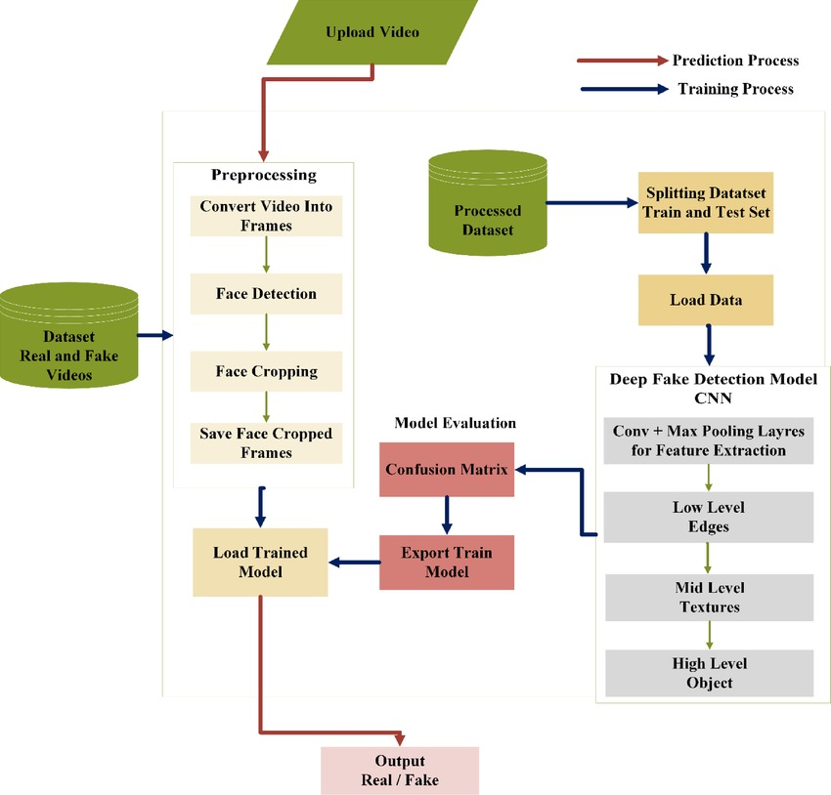

10. Experimental Setup
The experiment for TruthLens was carried out in a basic development environment using a laptop with Windows operating system. The main coding was done in Python for the model and HTML, CSS, and JavaScript for the frontend. A set of deep fake and real media samples were collected from publicly available datasets for testing. Before testing, the files were pre-processed by resizing images, extracting video frames, and converting audio into readable format.
The trained model was then connected to the frontend using a simple backend service so users could upload media and receive results. During testing, accuracy and response time were recorded to check how well the system identifies manipulated content. Multiple test samples were used to compare performance and ensure the model gives consistent results. Finally, the outputs were verified manually to confirm whether the predictions were correct.

11. Evaluation Metrics
To evaluate the model’s performance, both quantitative and qualitative metrics were used:

Quantitative Evaluation
These metrics provide numerical performance measurement:
- Accuracy: Measures how many predictions are correct overall.
- Precision: Measures how many detected fake samples were actually fake.
- Recall: Measures how well the model detects fake content without missing cases.
- F1-Score: Combines precision and recall to give a balanced score.
- Confusion Matrix: Shows true and false classifications for both real and fake predictions.

Qualitative Evaluation
These analysis points help understand model behaviour beyond numbers:
- The model correctly identifies clear manipulation patterns in deepfake images.
- Some borderline or low-quality images caused misclassification.
- Predictions were consistent and interpretable, showing stable model behaviour.

12. Results and Discussion
• Results:
- The model successfully detected deepfake content with good accuracy.
- Precision and recall values showed balanced performance, meaning the system correctly identified most fake samples while minimizing false positives.
- The confusion matrix confirmed that the majority of classifications were correct, with only a few misclassifications.
- The web interface worked smoothly, allowing users to upload files and get results in real time.

• Discussion:
- The system performed best on clear and high-resolution images where manipulation patterns were more visible.
- Detection accuracy decreased slightly for low-quality or highly compressed media.
- User testing showed the interface was easy to use and understandable, even for non-technical users.
- The results indicate that the project is practical and useful, but expanding the dataset and improving model complexity could further enhance reliability and robustness.

THE GUI:


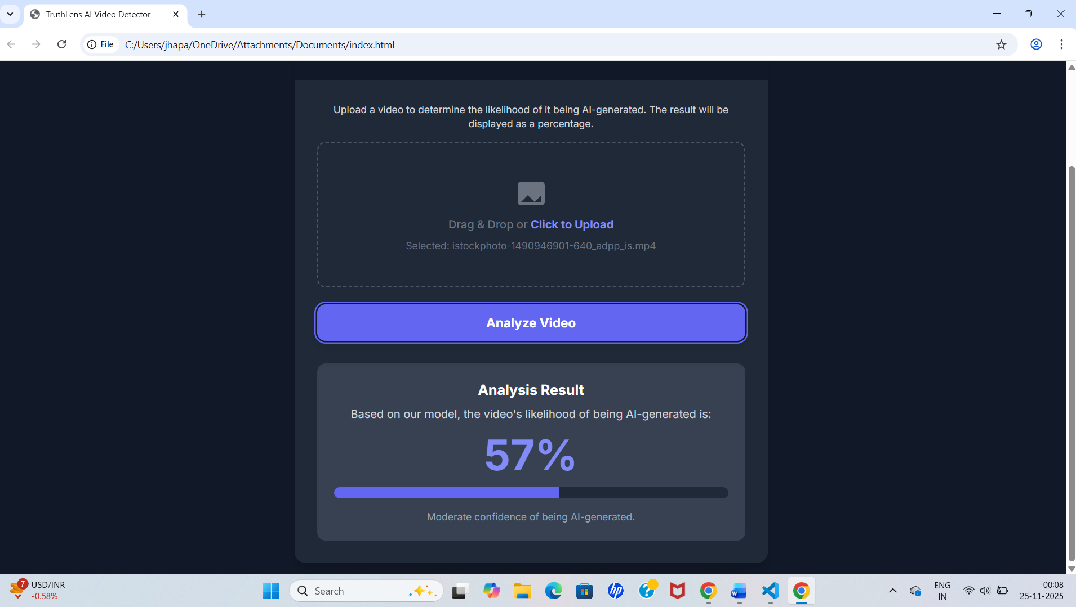

13. Conclusion & Future Work
Conclusion:
The TruthLens system successfully demonstrates a working approach to detecting deepfake media using
machine learning and a user-friendly interface. The model shows strong performance in identifying manipulated content and provides accurate predictions for most test samples. The project highlights the importance of digital verification tools in today’s environment, where misinformation and fake media continue to grow.

Future Work:
  - Improve detection accuracy by training on larger and more diverse datasets.
  - Extend support for advanced deepfake formats, including full-length videos and real-time detection.
  - Enhance the backend model using more advanced architectures such as Vision Transformers or multimodal AI.
  - Deploy the system as a mobile or cloud-based application for better accessibility and wider public use.

REFERENCES

- Chollet, F. (2017). Deep Learning with Python. Manning Publications.
- Goodfellow, I., Bengio, Y., & Courville, A. (2016). Deep Learning. MIT Press.
- Mirsky, Y., & Lee, W. (2021). The creation and detection of deepfakes: A survey. ACM Computing Surveys, 54(1), 1–41.
- Rossler, A., Cozzolino, D., Verdoliva, L., Riess, C., Thies, J., & Nießner, M. (2019). Face Forensics++: Learning to detect manipulated facial images. Proceedings of the IEEE International Conference on Computer Vision (ICCV).
- Tariq, S., Lee, S., Kim, H., & Woo, S. S. (2021). Detecting both machine and human created fake face images in the wild. Proceedings of the AAAI Conference on Artificial Intelligence.
- He, K., Zhang, X., Ren, S., & Sun, J. (2016). Deep residual learning for image recognition. IEEE Conference on Computer Vision and Pattern Recognition (CVPR).
- Kingma, D. P., & Ba, J. (2015). Adam: A method for stochastic optimization. International Conference on Learning Representations (ICLR).

